**CMPU 2016 Object Oriented Programming**

TU857-2

2024-25, Semester 1: Python with Sunder Ali Khowaja

[SunderAli.Khowaja@tudublin.ie](mailto:SunderAli.Khowaja@tudublin.ie)

**Lab 5: Polymorphism and Abstract Classes**

Welcome to Week 4 of the Object-Oriented Programming course! In this lab, you will delve deeper into the concepts of polymorphism and abstract structures. You will build upon the existing codebase from the previous weeks and incorporate new elements that demonstrate the power of polymorphism and abstract classes.

**Lab Duration**: 2 hours.

**Lab Objectives:**

* Understand the concept of polymorphism and its role in object-oriented programming.
* Learn to implement abstract classes and methods to provide a common interface for subclasses.
* Apply polymorphism and abstract structures to enhance the existing game code.
* Strengthen your ability to design and implement complex class hierarchies.

**Instructions:**

1. Open the Python code file from the previous week's lab. You can either use the solution file as a start point or your own Python file as long as yours fulfils all the requirements of last week’s lab.
2. Review the existing codebase, including the Character, Suspect, Witness, and Game classes.
3. Modify the **Character** class to become an abstract class by using the abc module's ABC class. Make sure to declare an abstract method called **perform_action**. Keep the other methods as they are.
4. Implement the perform_action method in the Suspect and Witness subclasses to demonstrate how to use an abstract method. Provide specific actions for each class’s method. What happens if you do not provide the method at all? Is it permissible to just use the transfer statement pass?
5. Update the Game class to utilize the new perform_action method for character interactions.
6. Extend your game with additional character interaction. Many games include so called non-playable characters (NPCs).
   1. Create a class derived from Character called NPC. Provide some logic for the NPC’s perform_action method.
   2. In the Game’s interact_with_characters method, provide an option for the player to choose between interacting with a witness and suspect or with other people in the room (aka, the NPCs).
   3. If the player chooses to interact with other people, now create a friendly, a hostile and an indifferent NPC instance. For example dialogues see below for an example game being played. Create a list of these characters and use a for-loop to cycle through your NPC characters and call the character’s interact and perform_action methods.
7. Test the modified game to observe how polymorphism and abstract structures enhance the gameplay experience.
8. Answer the quiz questions and upload your code. This lab is marked. A solution is available from tomorrow on. The solution code will be discussed in the next lecture. Your solution will likely differ from mine. If you fulfil the task description this is not a problem and is to be expected. If you have questions after reviewing the solution please contact me asap via email.

**Class Diagram for this Week’s Lab Submission:**

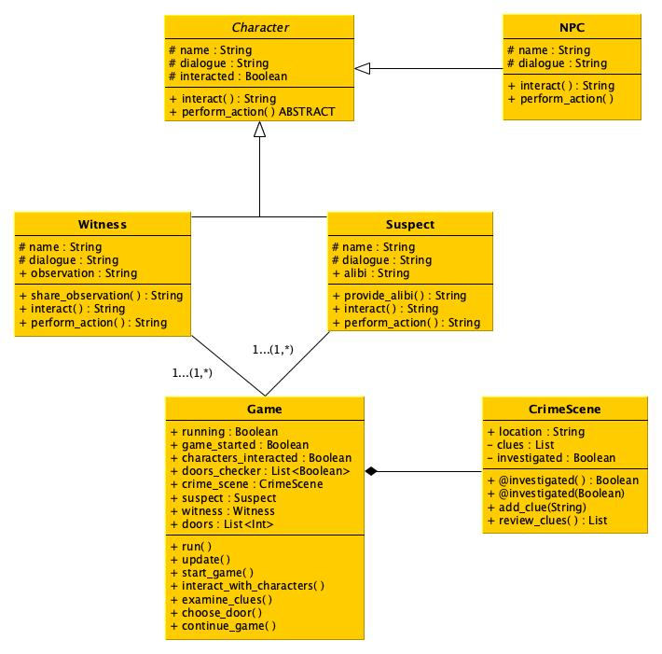

*Fig.1: Class Diagram for this week’s lab*

**Example Game Play:**

Welcome to 'The Poirot Mystery'

You are about to embark on a thrilling adventure as a detective.

Your expertise is needed to solve a complex case and unveil the truth.

Press 'q' to quit or 's' to start: s

Enter your detective's name: Ali

Welcome, Detective Ali!

You find yourself in the opulent drawing room of a grand mansion.

As the famous detective, you're here to solve the mysterious case of...

'The Missing Diamond Necklace'.

Put your detective skills to the test and unveil the truth!

Press 'q' to quit, 'c' to continue, 'i' to interact, 'e' to examine clues, 'r' to review clues, or 'd' to choose a door: c

You continue your investigation, determined to solve the mystery...

Press 'q' to quit, 'c' to continue, 'i' to interact, 'e' to examine clues, 'r' to review clues, or 'd' to choose a door: r

You have not found any clues yet.

Press 'q' to quit, 'c' to continue, 'i' to interact, 'e' to examine clues, 'r' to review clues, or 'd' to choose a door: e

You decide to examine the clues at the crime scene.

You find a torn piece of fabric near the window.

Press 'q' to quit, 'c' to continue, 'i' to interact, 'e' to examine clues, 'r' to review clues, or 'd' to choose a door: r

['Torn fabric']

Press 'q' to quit, 'c' to continue, 'i' to interact, 'e' to examine clues, 'r' to review clues, or 'd' to choose a door: i

You decide to interact with the characters in the room.

If you want to speak to the witness and a suspect, choose 1.

If you'd like to speak to other people in the room, choose 2: 1

You decide to interact with the witness and suspect in the room:

Mr. Smith: I was in the library all evening.

Mr. Smith's Alibi: Confirmed by the butler.

Suspect Mr. Smith nervously shifts and avoids eye contact.

Ms. Parker: I saw someone near the window at the time of the incident.

Ms. Parker's Observation: Suspicious figure in dark clothing.

Witness Ms. Parker speaks hurriedly and glances around anxiously.

Press 'q' to quit, 'c' to continue, 'i' to interact, 'e' to examine clues, 'r' to review clues, or 'd' to choose a door: r

['Torn fabric', 'Mr. Smith: I was in the library all evening.', "Mr. Smith's Alibi: Confirmed by the butler.", 'Ms. Parker: I saw someone near the window at the time of the incident.', "Ms. Parker's Observation: Suspicious figure in dark clothing."]

Press 'q' to quit, 'c' to continue, 'i' to interact, 'e' to examine clues, 'r' to review clues, or 'd' to choose a door: i

You decide to interact with the characters in the room.

If you want to speak to the witness and a suspect, choose 1.

If you'd like to speak to other people in the room, choose 2: 1

You have already interacted with the characters. They no longer wish to speak to you.

Press 'q' to quit, 'c' to continue, 'i' to interact, 'e' to examine clues, 'r' to review clues, or 'd' to choose a door: i

You decide to interact with the characters in the room.

If you want to speak to the witness and a suspect, choose 1.

If you'd like to speak to other people in the room, choose 2: 2

You decide to speak to other people in the room:

Beatrice: How do you do.

Beatrice decides to hang around and see what will happen.

Seamus: Welcome to our village.

Seamus decides to hang around and see what will happen.

Evil Goblin: Leave this place!

Evil Goblin decides to hang around and see what will happen.

Press 'q' to quit, 'c' to continue, 'i' to interact, 'e' to examine clues, 'r' to review clues, or 'd' to choose a door: r

['Torn fabric', 'Mr. Smith: I was in the library all evening.', "Mr. Smith's Alibi: Confirmed by the butler.", 'Ms. Parker: I saw someone near the window at the time of the incident.', "Ms. Parker's Observation: Suspicious figure in dark clothing.", 'Three people are hanging around the scene who have nothing to do with the crime.']

Press 'q' to quit, 'c' to continue, 'i' to interact, 'e' to examine clues, 'r' to review clues, or 'd' to choose a door: d

You decide to choose a door to investigate:

1. Front door

2. Library door

3. Kitchen door

Enter the number of the door you want to investigate: 1

As you approach the front door, you hear a faint whisper... The plot thickens!

Press 'q' to quit, 'c' to continue, 'i' to interact, 'e' to examine clues, 'r' to review clues, or 'd' to choose a door: r

['Torn fabric', 'Mr. Smith: I was in the library all evening.', "Mr. Smith's Alibi: Confirmed by the butler.", 'Ms. Parker: I saw someone near the window at the time of the incident.', "Ms. Parker's Observation: Suspicious figure in dark clothing.", 'Three people are hanging around the scene who have nothing to do with the crime.', 'faint whisper near kitchen']

Press 'q' to quit, 'c' to continue, 'i' to interact, 'e' to examine clues, 'r' to review clues, or 'd' to choose a door: d

You decide to choose a door to investigate:

1. Front door

2. Library door

3. Kitchen door

Enter the number of the door you want to investigate: 2

You open the library door to reveal a hidden passage... What secrets does it hold?

Press 'q' to quit, 'c' to continue, 'i' to interact, 'e' to examine clues, 'r' to review clues, or 'd' to choose a door: r

['Torn fabric', 'Mr. Smith: I was in the library all evening.', "Mr. Smith's Alibi: Confirmed by the butler.", 'Ms. Parker: I saw someone near the window at the time of the incident.', "Ms. Parker's Observation: Suspicious figure in dark clothing.", 'Three people are hanging around the scene who have nothing to do with the crime.', 'faint whisper near kitchen', 'hidden passage behind library door']

Press 'q' to quit, 'c' to continue, 'i' to interact, 'e' to examine clues, 'r' to review clues, or 'd' to choose a door: d

You decide to choose a door to investigate:

1. Front door

2. Library door

3. Kitchen door

Enter the number of the door you want to investigate: 3

You open the kitchen door. The mansion's chef prepares the evening meal. No clues to the mystery can be unveiled.

Press 'q' to quit, 'c' to continue, 'i' to interact, 'e' to examine clues, 'r' to review clues, or 'd' to choose a door: d

You decide to choose a door to investigate:

1. Front door

2. Library door

3. Kitchen door

Enter the number of the door you want to investigate: 3

You've looked in the kitchen already.

Press 'q' to quit, 'c' to continue, 'i' to interact, 'e' to examine clues, 'r' to review clues, or 'd' to choose a door: r

['Torn fabric', 'Mr. Smith: I was in the library all evening.', "Mr. Smith's Alibi: Confirmed by the butler.", 'Ms. Parker: I saw someone near the window at the time of the incident.', "Ms. Parker's Observation: Suspicious figure in dark clothing.", 'Three people are hanging around the scene who have nothing to do with the crime.', 'faint whisper near kitchen', 'hidden passage behind library door']

Press 'q' to quit, 'c' to continue, 'i' to interact, 'e' to examine clues, 'r' to review clues, or 'd' to choose a door: q